B.PRASANTH

192110025

CSA4053-MIs

3.CONNECTIVITY PROGRAM FOR PAYROLL SYSTEM

FORM:-

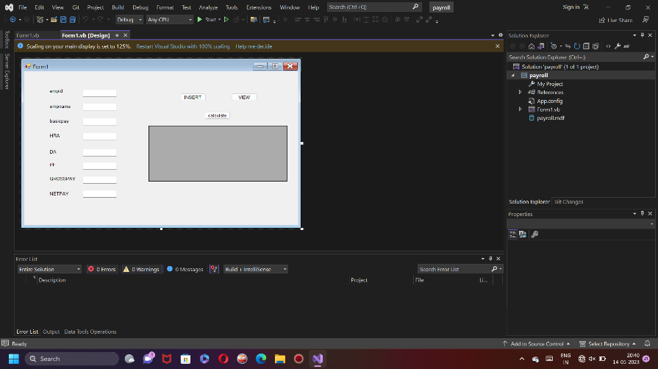

DATABASE:-

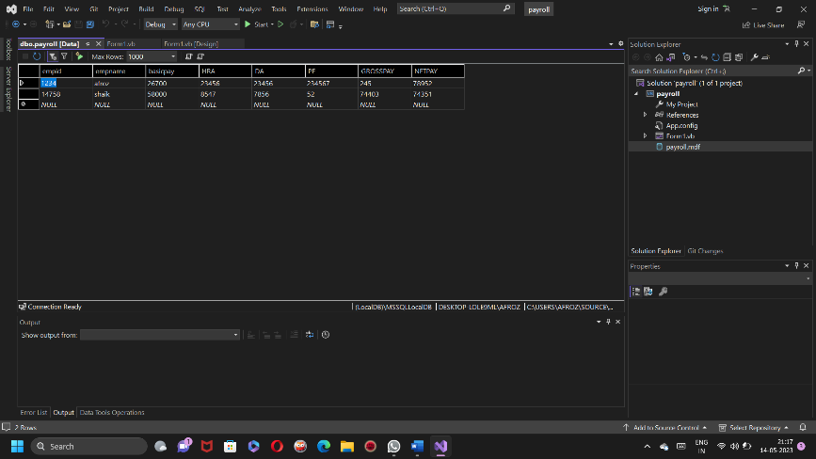

CODE:-

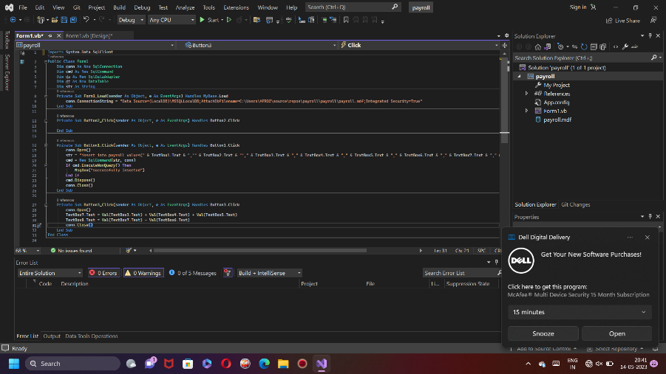

OUTPUT:-

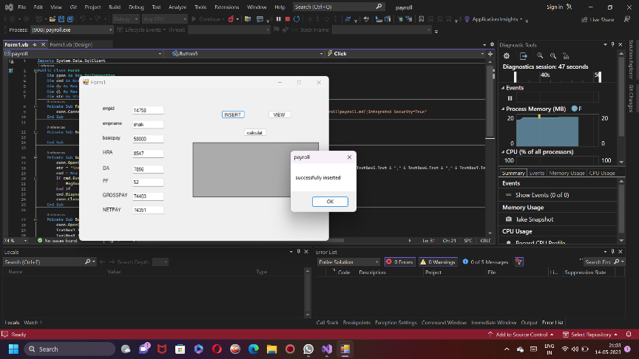

4.CONNECTIVITY PROGRAM FOR STUDENT MARKSHEET

FORM:-

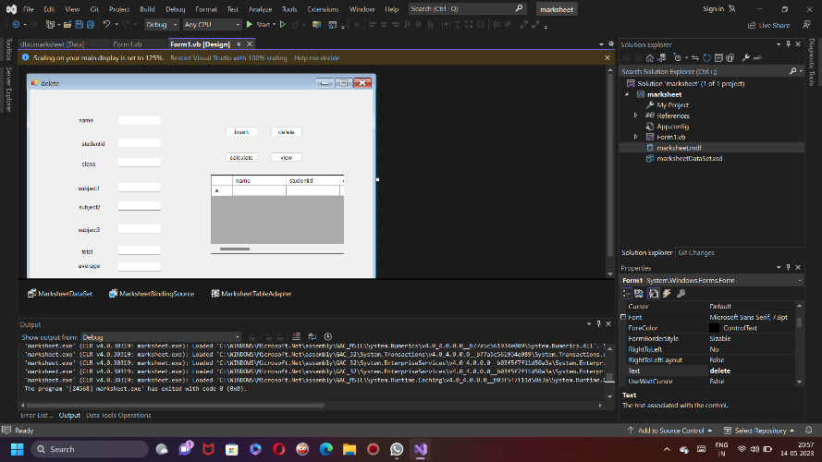

DATABASE:-

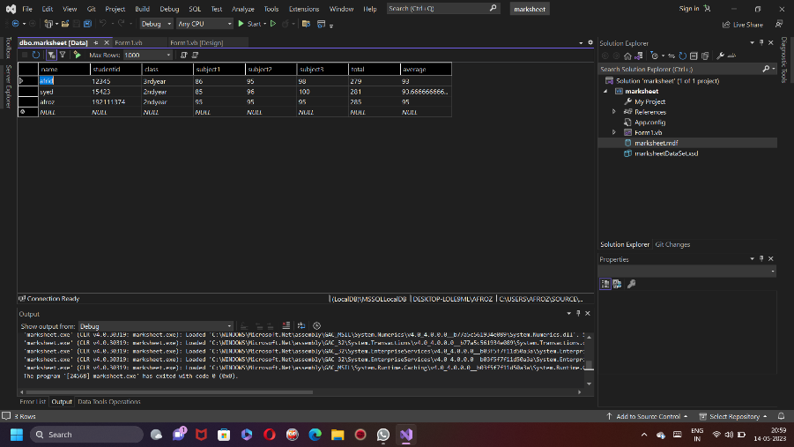

CODE:-

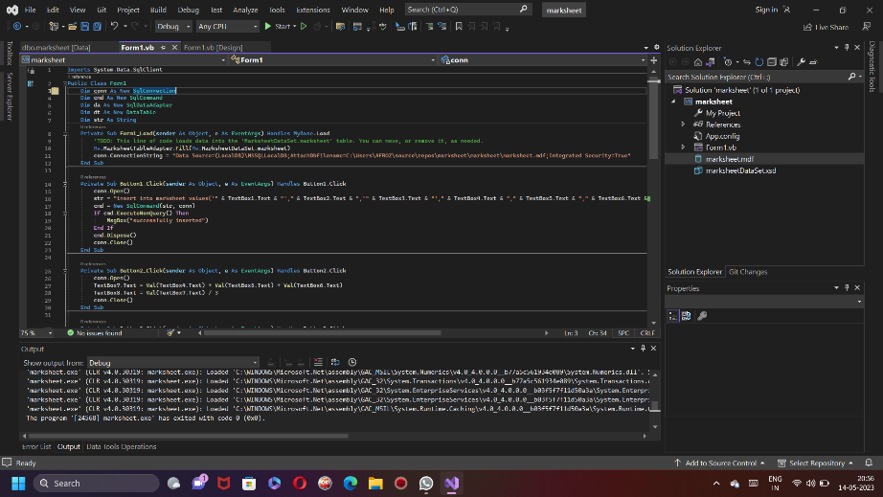

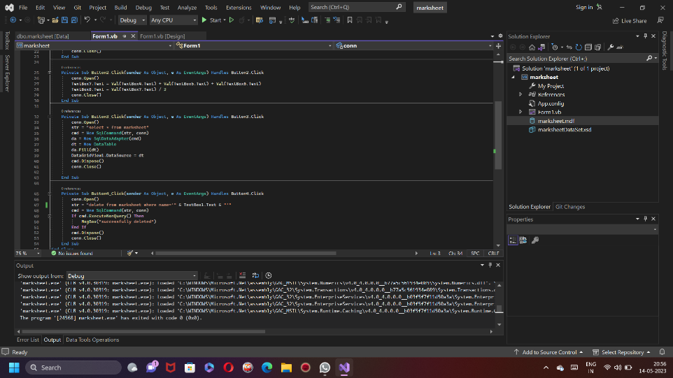

OUTPUT:-

